CEF: Cybersecurity Digital Service Infrastructure;

|  |  |
| --- | --- |
| **Version:** | **0.0.1** |
| **Date:** | **23/06/2019** |

Core Service Platform – SMART 2015/1089

**MISP v.2.4.107 Post Installation Manu****al**

Contents

1 Introduction 4

Prerequisities 4

2 Latest MISP installation 5

3 MISP re-configuration 6

# Introduction

This manual covers the post installation of latest MISP (version 2.4.107) that is delivered with CSP version 4.2 modules.

## Prerequisities

Before starting the procedure of updating to the latest MISP please make sure you have prepared the following:

* You have noted the password of the local MISP administrator. According to CSP Administration Manual, Chapter 8 – MISP Administration, local MISP Administrator should have username: [integration@melicertes.eu](mailto:integration@melicertes.eu). In case you do have not noted user’s password during MISP first time configuration, **you should change and note it**, before proceeding with update.
* Latest MISP module has been assigned to you CSP instance.

# Latest MISP installation

You have to proceed with MISP module installation as described in CSP Installation Manual, Chapter 5 – Installation and Chapter 6 – Managinh CSP.

# MISP re-configuration

After installing latest MISP module (v2.4.107) and starting CSP instance when trying to access MISP’s web interface, via: https://misp-ui.{cspID.}{cspEnv.}melicertes.eu you will notice that integration with OpenAM for Single Sign On has broken and you will prompted with the MISP’s login screen, as shown in following screenshot:

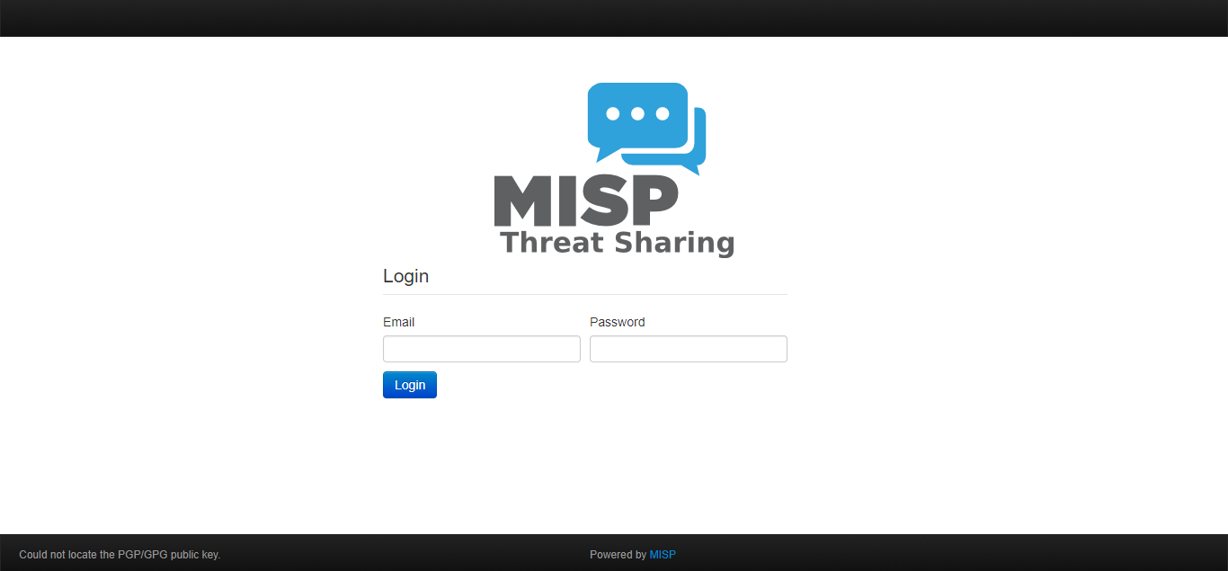

At this point you have to use MISP local administrator user to login and proceed with the configurations, as noted in the Prerequisities of this guide. Remember, that if MISP has been successfully configured in its previous installation the local administrator account will be the one with username: [integration@melicertes.eu](mailto:integration@melicertes.eu).

After successful login with the local MISP administrator account you have to **re-apply the following settings**.

**IMPORTANT NOTICE:**

Even if some of the settings listed below will look like already configured (assigned with the correct values) you have to re-assign these values so as MISP will trigger their update,

Basic MISP settings

From the top menu navigate to: Administration 🡪 Server Settings 🡪 MISP settings and set the following values:

* MISP.live = true
* MISP.baseurl = https://misp-ui.{cspID.}{cspEnv.}melicertes.eu, where {cspID} and {cspEnv} should match your CSP instance ID and environment, respectively
* MISP.Org: CSP::{csp-id}

ZeroMQ settings

From the top menu navigate to: Administration 🡪 Server Settings 🡪 Plugin settings 🡪 ZeroMQ and **re-apply all values**, as they are mentioned in CSP Administration Manual. For your convinience the values are copied also here:

|  |  |
| --- | --- |
| **Setting** | **Value** |
| Plugin.ZeroMQ_enable | true |
| Plugin.ZeroMQ_user_notifications_enable | true |
| Plugin.ZeroMQ_audit_notifications_enable | True |
| Plugin.ZeroMQ_event_notifications_enable | True |

SSO settings

From the top menu navigate to: Administration 🡪 Server Settings 🡪 Plugin settings 🡪 CustomAuth and **re-apply all values**, as they are mentioned in CSP Administration Manual. For your convinience the values are copied also here:

|  |  |
| --- | --- |
| **Setting** | **Value** |
| Plugin.CustomAuth_enable | true |
| Plugin.CustomAuth_header | CUSTOM_USER_ID |
| Plugin.CustomAuth_use_header_namespace | true |
| Plugin.CustomAuth_header_namespace | HTTP_ |
| Plugin.CustomAuth_required | false |
| Plugin.CustomAuth_only_allow_source |  |
| Plugin.CustomAuth_name | External authentication |
| Plugin.CustomAuth_disable_logout | true |
| Plugin.CustomAuth_custom_password_reset |  |
| Plugin.CustomAuth_custom_logout | /logout/ |

At this point you can navigate to: Administration 🡪 List Users and verify that tyhere is at least one External user with email: {userid}@{cspId.}{cspEnv.}melicertes.eu and External Auth Key = {userId}.

You can now close all browsers tabs and windows and try to login in MISP UI with the SSO user.

- End of document-